Exercise 2: Implementing Dependency Injection
To manage the dependencies between the BookService and BookRepository classes using Spring's IoC and DI we need to update applicationContext.xml to wire BookRepository into BookService.

So we need to use the instance of BookRepository class inside BookService class but not by directly creating the object using new keyword, it is automatically done by the spring.

We need to create a variable of BookRepository type and spring initializes that variable in run time using DI. That DI can be in two ways
1)via constructor injection
2)via setter injection
Setter injection:
Write a set method to initialize the BookRepository type variable
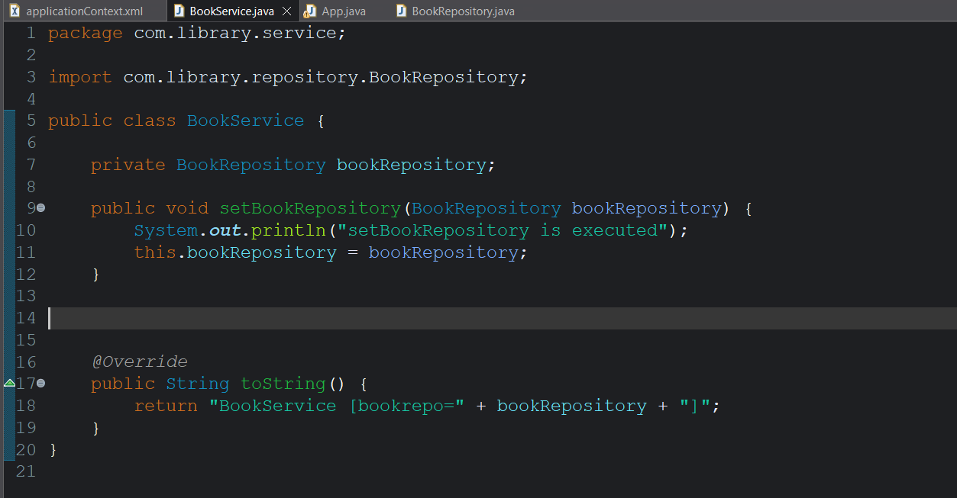
This bookRepository variable is initialized by the bean created for BookService class using BookReposiory reference
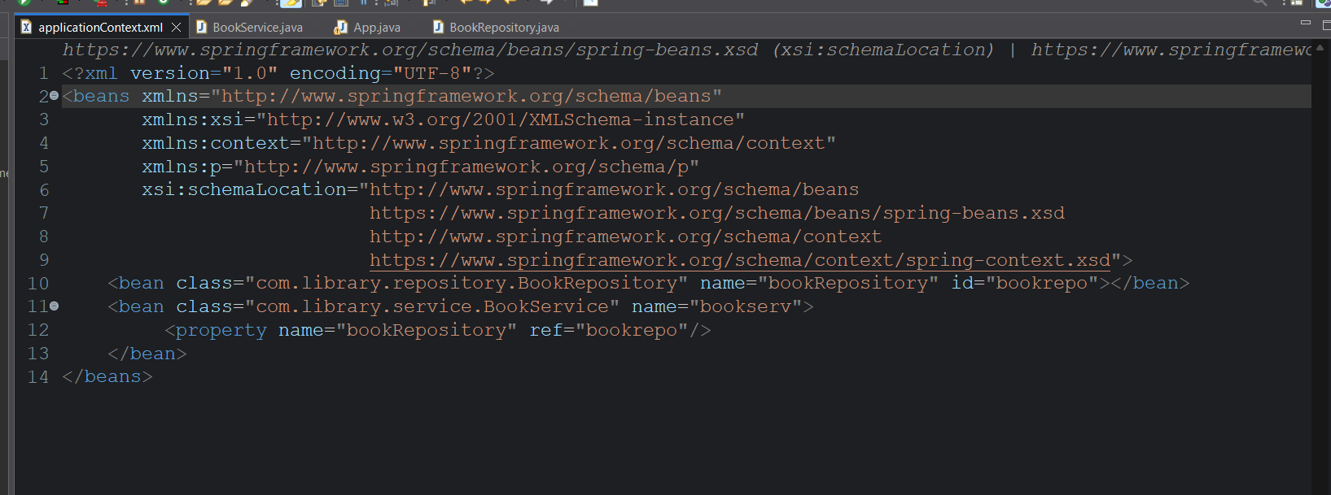
Incase of primitive types
We will initialize like
<bean class="excat path of class" name="name to call the bean">
<property name="property1">
<value>value1</value>
</property>
<property name="property2">
<value>value2</value>
</property>
. . .
</bean>
Since class is not a primitive type i.e.,(user defined type)
<bean class="exact path of class1" name="name for calling" id="id to uniquely identify">
. . .
</bean>

<bean class="exact path of class2" name="name for calling">
<property name=”class1 name” ref=”class1 id”/>
</bean>

The class2 has variable of class1 type. Bean2 uses ref to identify bean1 and calls it using the name attribute.

Test it from main class
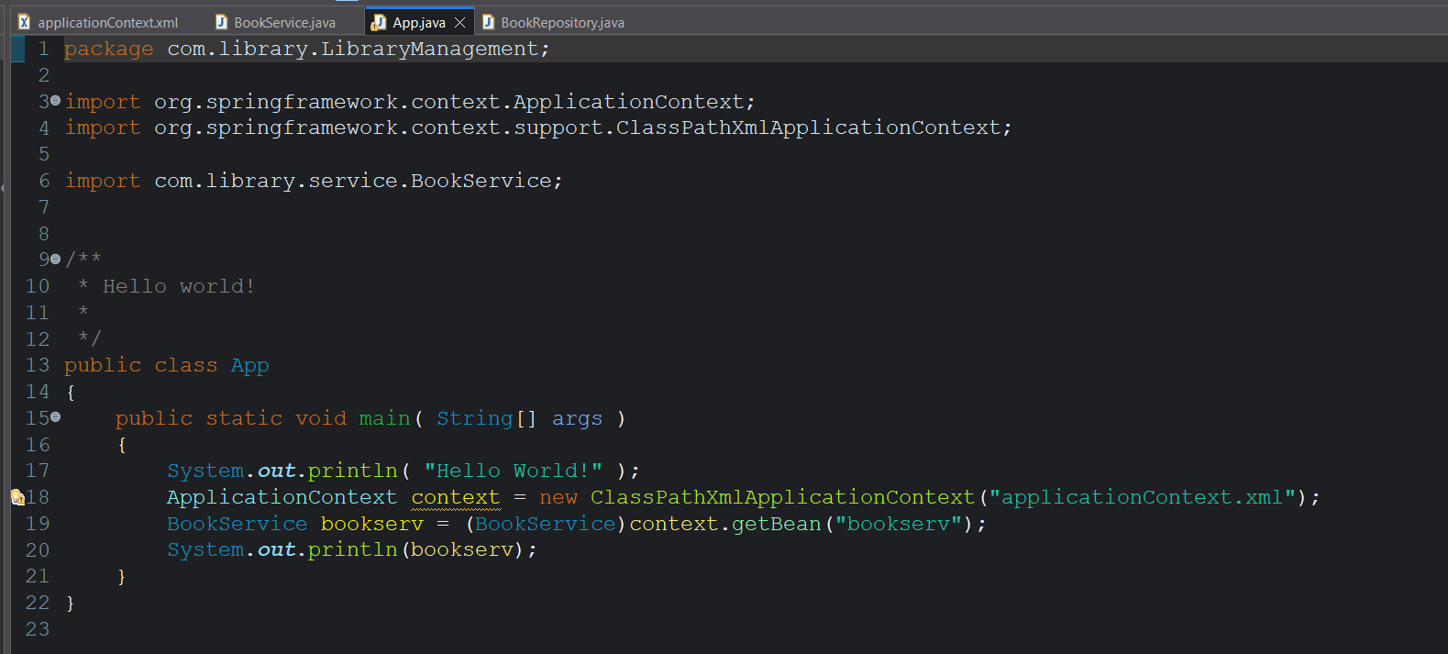
Output:
